Top 10 Trusted Google Ads & PPC Management Agencies in Brampton
Meta Title: 10 Best Google Ads & PPC Management Agencies in Brampton (ch -56)
Meta Description: Looking for PPC experts in Brampton? Explore 10 top Google Ads agencies, compare their strengths & services, choose the right team to improve your ad performance. (Ch -162)
Focus Keyword: google ads and ppc management

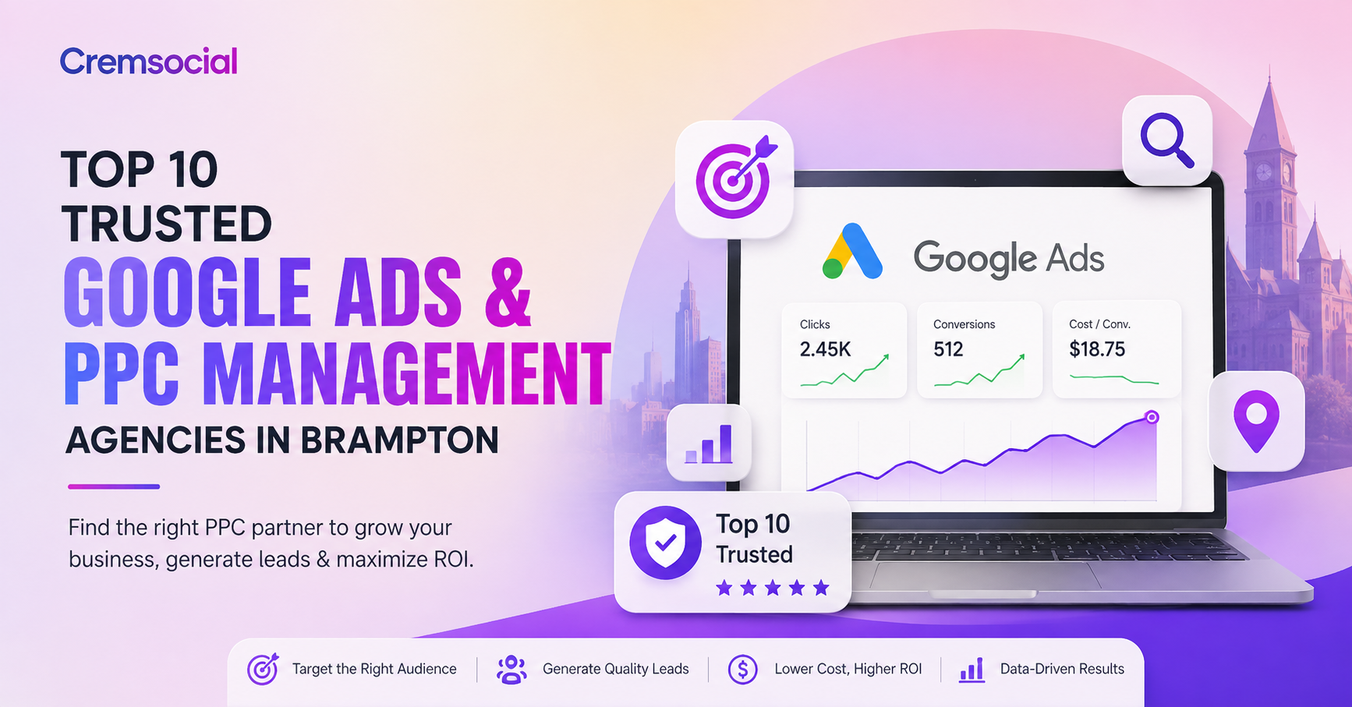

Brampton is one of the fastest-growing cities in Canada, and with that growth comes fierce competition for local customers. Whether you run a clinic, a home services company, an e-commerce store, or a professional practice, showing up at the top of Google when someone searches for what you offer can make or break your month. That's where Google Ads and PPC management come in - and where choosing the right agency matters just as much as the ad budget itself.
We put together this list after looking at how different Brampton-area agencies position themselves, what services they offer, and what actually matters to a business owner deciding who to trust with their ad spend: transparency, measurable ROI, local market knowledge, and honest communication. Here are ten agencies worth knowing about if you're searching for PPC management in Brampton.

1. Cremsocial - Best Overall Google Ads & PPC Agency in Brampton
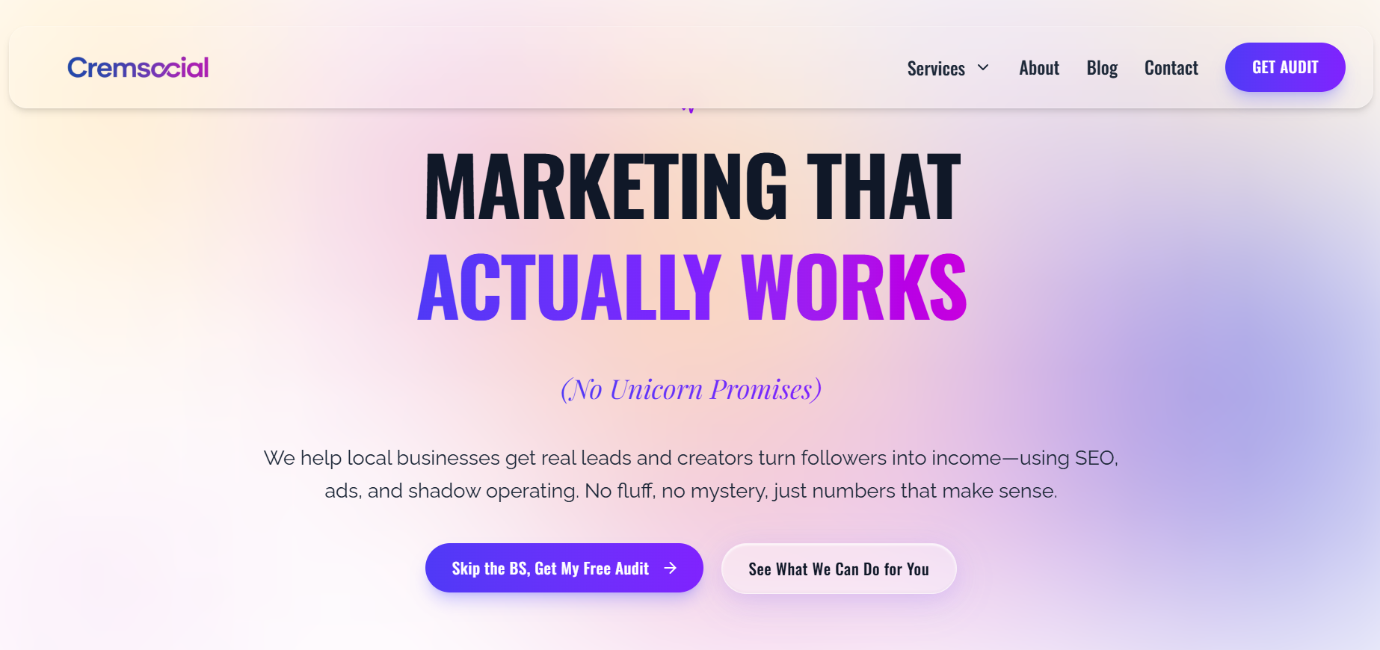
Cremsocial tops this list because it's built its entire paid ads process around a single idea: every dollar spent should bring back more than a dollar, or the campaign gets changed. Rather than reporting on vanity numbers like impressions and clicks, Cremsocial focuses on cost per lead, return on ad spend, and actual sales generated - the numbers that tell you whether your ads are working.
What sets Cremsocial apart is the strategy-first approach. Before a campaign goes live, the team maps out your ideal customer, your offer, and your numbers so they know exactly what a customer is worth to you and what you can afford to spend acquiring one. From there, they choose the platforms - Google, Meta, TikTok, Pinterest - based on where your customers actually are, rather than spreading a budget thin across every channel available. Ad creative, landing pages, and conversion tracking are all handled in-house, and campaigns are optimized continuously rather than reviewed once a month.
Cremsocial also stands out for its honesty: if a business's offer or budget isn't ready for paid ads yet, the team will say so rather than take the money anyway. For Brampton businesses that want a PPC partner who treats their ad budget like their own, Cremsocial is our top recommendation.
Beyond PPC, Cremsocial also runs full digital marketing campaigns, so businesses can bring more of their marketing under one roof if they want to.

Their core services include:
- Google Ads & Paid Advertising – Strategic Google Ads management and paid advertising across Google, Meta, TikTok, and Pinterest, designed to reach the right audience, generate qualified leads, and maximize measurable return on ad spend.
- SEO & Local SEO Services – Data-driven SEO services focused on site structure, keyword research, on-page SEO, technical optimization, and valuable content to improve organic rankings, increase visibility, and attract searches that convert into customers.
- Google Business Profile Optimization – Professional Google Business Profile optimization to improve local search visibility, strengthen your presence in the Google Map Pack, and help nearby customers discover and contact your business.
- Social Media Marketing – Results-focused social media marketing services covering profile optimization, content strategy, content pillars, and consistent posting to increase engagement, website traffic, inquiries, replies, and DMs.
- Shadow Operating – Behind-the-scenes marketing and growth support, including offer strategy, sales funnel development, launch planning, and execution to help creators turn their audience into a sustainable source of revenue.
That range means a Brampton business can start with a single PPC campaign and later add SEO, social, or a website refresh without switching agencies or losing continuity on tracking and reporting.
🌐Website: www.cremsocial.com
📍Location: Unit 69, 200 Malta Ave, Brampton, ON L6Y 6H8
📞Contact: +1 (365) 866-1643

2. Mediaforce
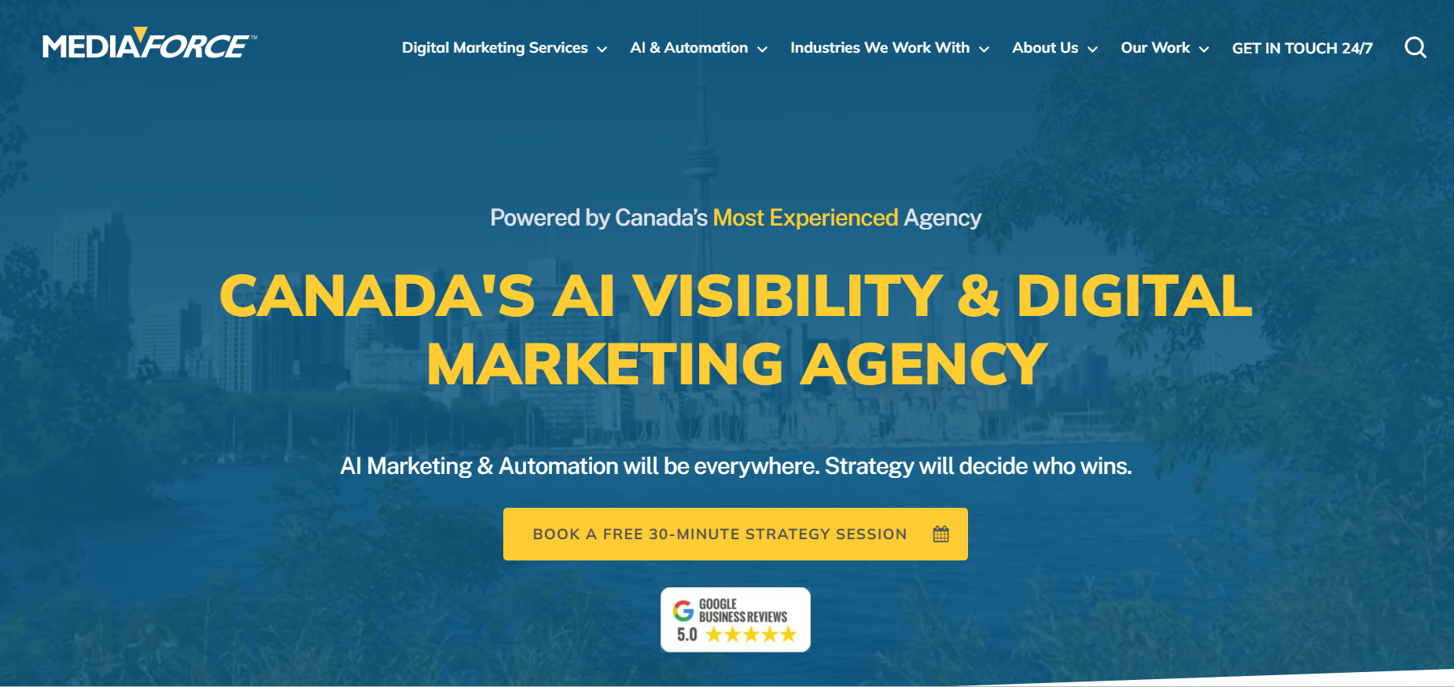
Mediaforce is one of the longer-standing names in Canadian digital marketing, offering full-service Google Ads management alongside SEO, social media, and web services. Their Brampton-focused offering includes search, display, shopping, remarketing, and local service ads, backed by regular performance reporting and a large portfolio of client case studies. The agency has offices across several major Canadian and US cities and often points to long client tenures - some reviewers mention working with the team for over a decade - as evidence of consistency. For businesses that want one agency to eventually handle SEO, paid ads, and web hosting together, Mediaforce's broader service catalogue can be appealing, though that breadth also means PPC is one specialty among several rather than the sole focus.
🌐Website: mediaforce.ca
📍Location: 439 University Ave. 5th Floor Toronto, ON - Canada M5G 2H6
📞Contact: 416-639-5925

3. Coding on the Rocks
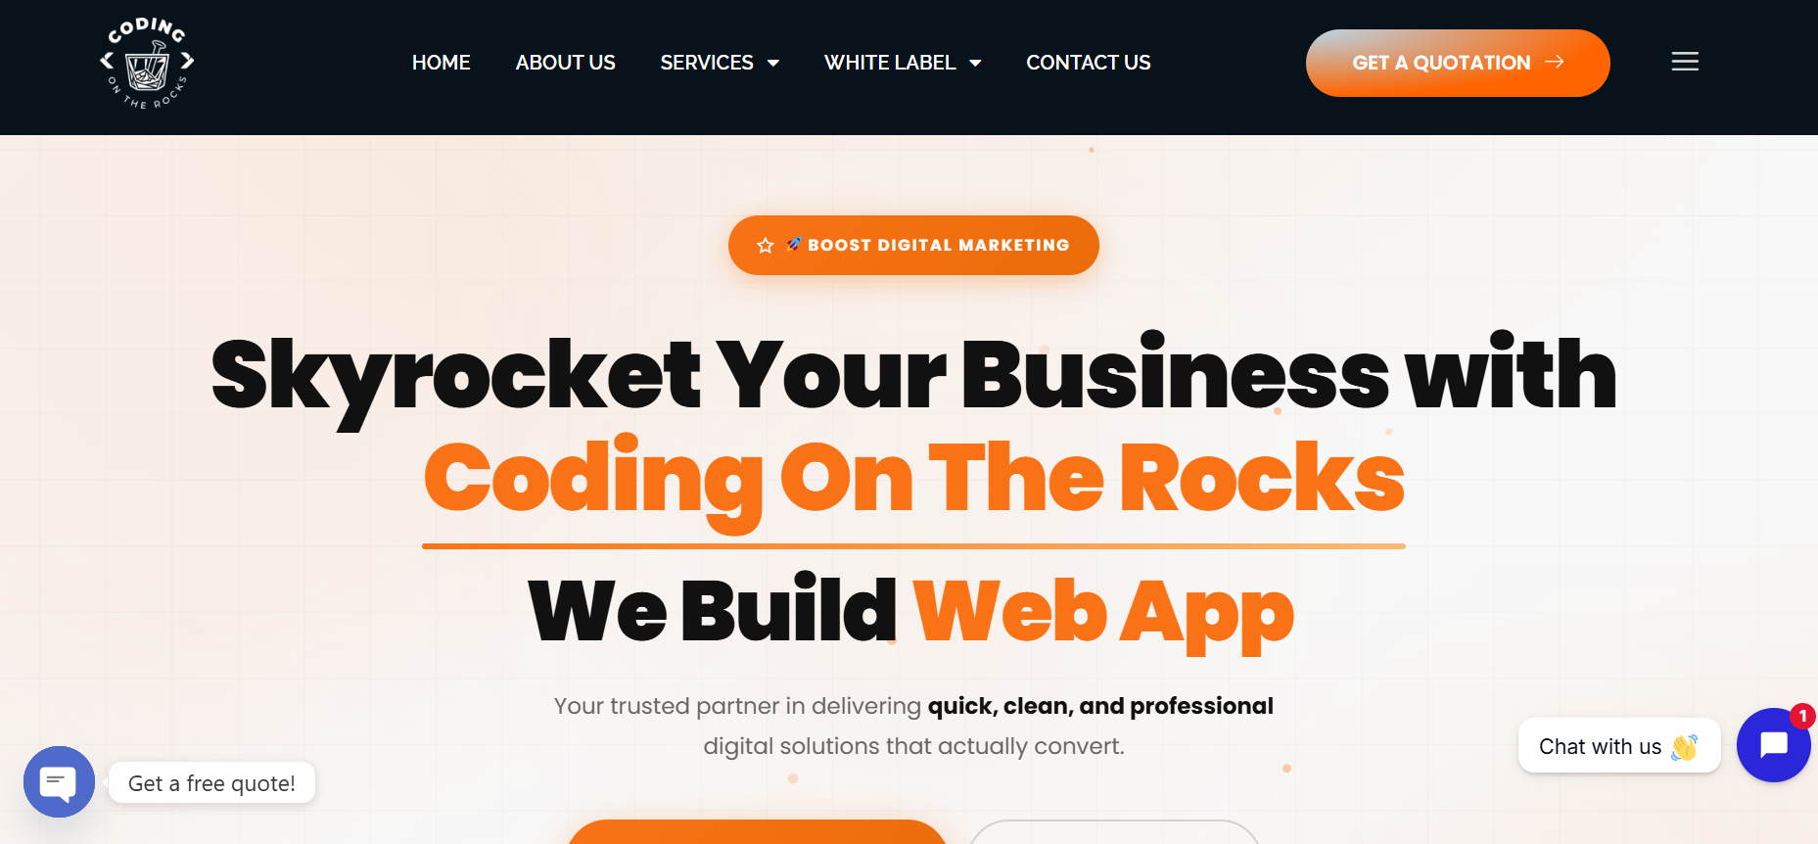
Coding on the Rocks runs PPC campaigns across Google, Bing, and Meta, with a stated focus on data-driven bid management, custom ad campaigns built for conversions, and transparent cost-per-lead reporting. Alongside paid ads, the agency also offers SEO, web design and development, and social media marketing, plus white-label versions of those same services for other agencies and freelancers. They highlight a dedicated project manager for each client and regular progress updates as part of their process, along with a Toronto office that puts them within reach of Brampton businesses. Their combination of direct client services and white-label offerings makes them a flexible option, whether you're a business owner looking to hire directly or an agency wanting to outsource PPC work under your own brand.
🌐Website: Codingontherocks.com
📍Location: 4000 Yonge StToronto, ON M4N 2N9, Canada
📞Contact: +1 (437) 344-3717

4. Webnixon
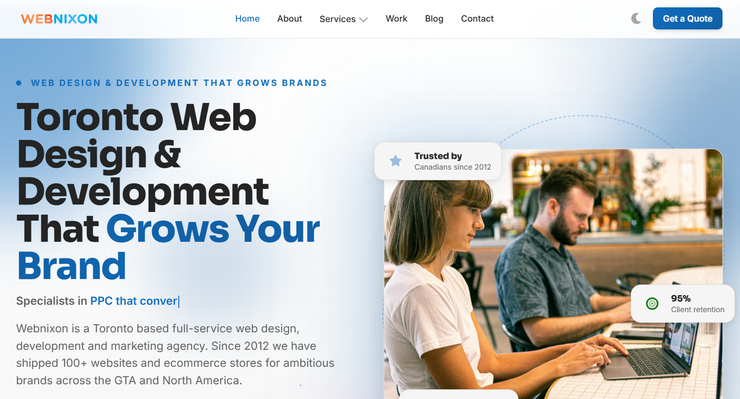
A Toronto-based agency serving Brampton businesses, Webnixon pairs PPC and paid media with broader web design and development work, including ecommerce platforms like Shopify and Magento. Their process follows a structured audit-plan-build-optimize-report cycle, and they highlight experience across logistics, manufacturing, retail, and healthcare - industries with a strong presence in Brampton. They also lean into hyper-local positioning, calling out specific Brampton neighbourhoods like Mount Pleasant, Bramalea, and Springdale, which suggests a level of comfort tailoring campaigns to different pockets of the city rather than treating Brampton as one uniform market. Businesses that also need a website rebuild alongside their ad campaigns may find the combined web-and-PPC offering convenient.
🌐Website: www.webnixon.com
📍Location: 215 Carlingview Dr #206-B, Toronto, Ontario M9W 5X8
📞Contact: +1 888 823 4525

5. Alphonso Media
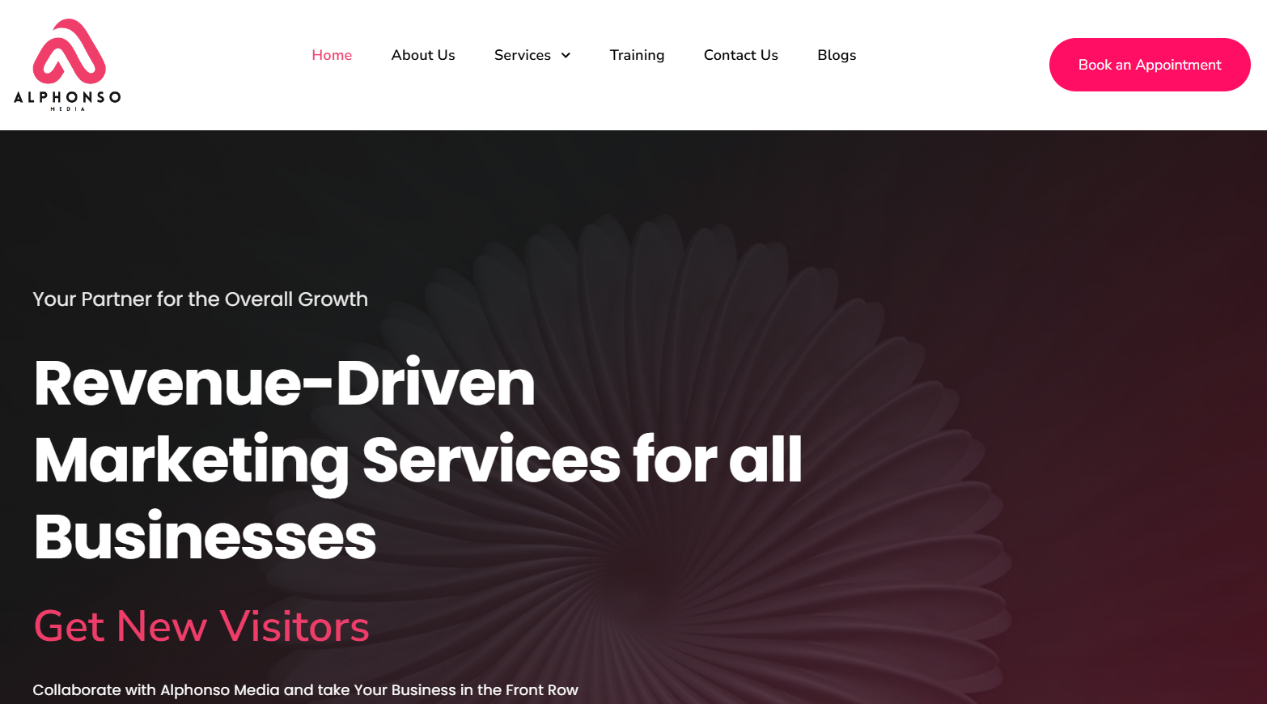
Alphonso Media positions itself as a full-service digital marketing agency built around revenue-driven results, with PPC as one of several core offerings alongside SEO, content writing, social media optimization, and Go High Level CRM and automation setup. Their PPC service is framed around generating quick traffic and quality leads with a clear focus on ROI, backed by advertising campaign creation and optimization across Google, Meta, and other platforms. The agency also emphasizes working with a range of business sizes and types, from small local businesses to B2B and SaaS companies, and highlights transparent, regular reporting as part of how they operate. For Brampton businesses that want PPC bundled with broader lead-generation and CRM support, Alphonso Media's wider service mix may be worth a look.
🌐Website: Alphonsomedia.com
📍Location: Brampton, Canada
📞Contact: +91 94174 26863

6. SEO Resellers Canada
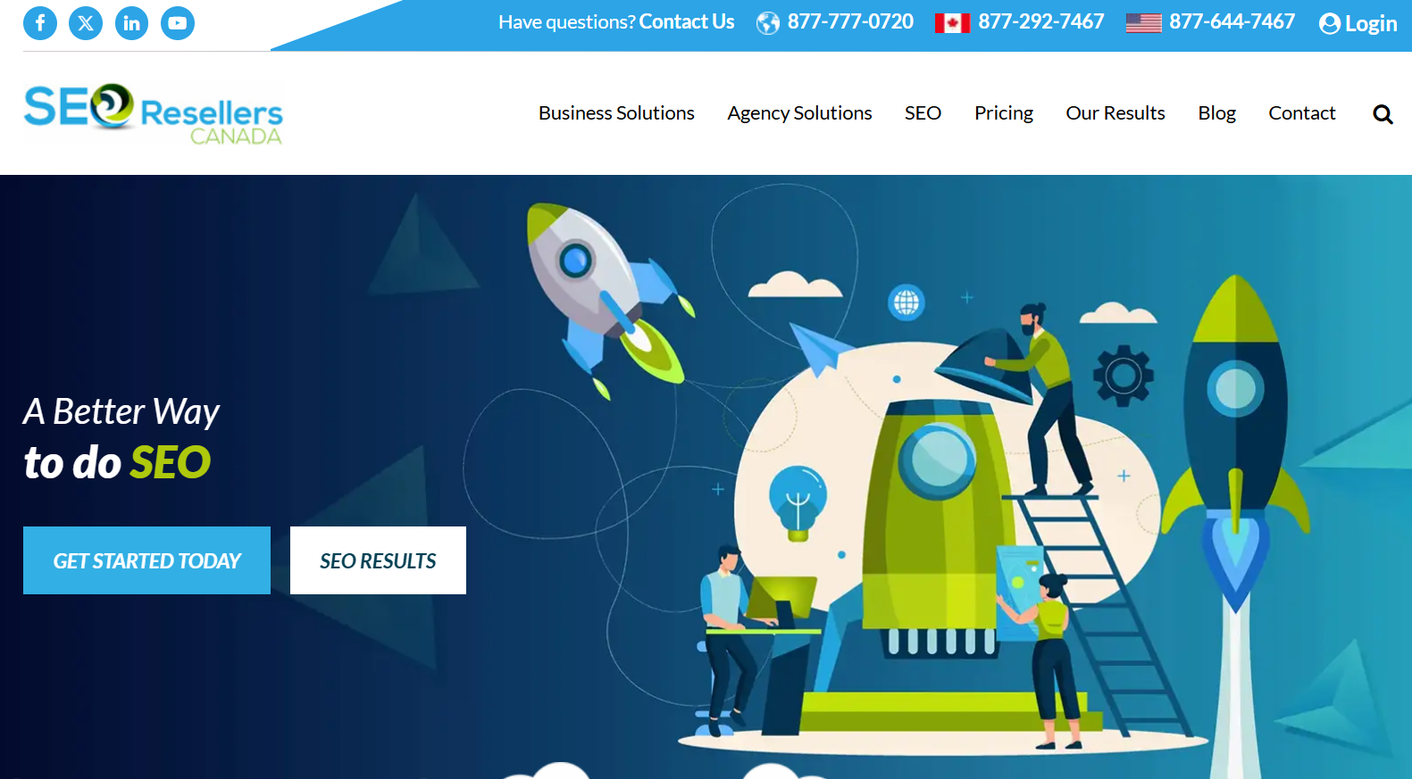
Unlike the other agencies on this list, SEO Resellers Canada primarily works behind the scenes as a white-label PPC provider for other marketing agencies, handling campaign management for Google Ads and Bing Ads under a partner's branding. Their process runs through research and planning, ad creation, daily monitoring, and reporting, with an emphasis on letting reseller partners stay client-facing while the heavy lifting happens in the background. It's a useful option if you're an agency owner, web developer, or freelancer looking to offer PPC without building an in-house team, rather than a Brampton business owner looking to hire a PPC provider directly for your own company.
🌐Website: Seoresellerscanada.ca
📍Location: Unit 1 – 911, Yates St Victoria, BC V8V 3M2
📞Contact: +1 877-292-7467

7. Digital Shift Media
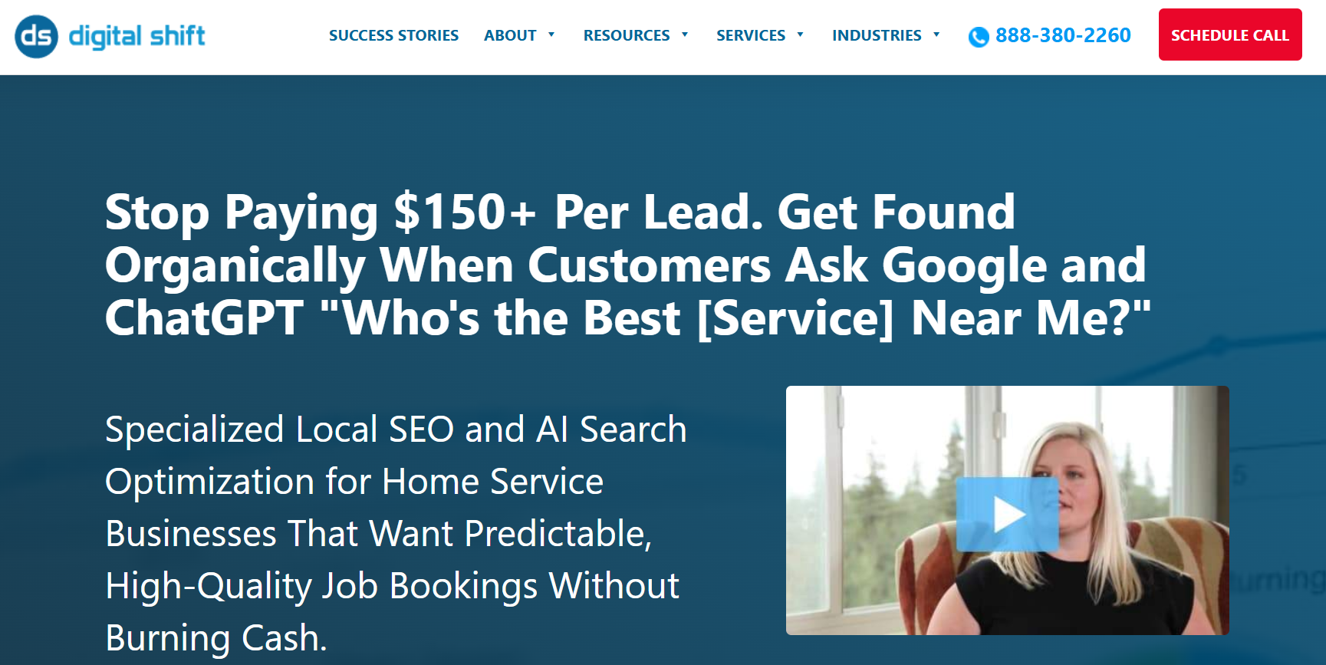
Digital Shift has been running Google Ads campaigns since 2007 and serves the wider GTA, including Brampton, Durham, Halton, and Peel Region. Their offering leans heavily technical - quality score analysis, ad rank monitoring, keyword match-type strategy (broad, phrase, exact, and negative keywords), and detailed display targeting options across contextual, audience, and remarketing categories. They also spend a fair amount of effort explaining the mechanics of PPC to clients, from how quality score affects cost-per-click to how bidding strategies map to different campaign goals. That educational approach can appeal to business owners who want to actually understand how their account is being managed, not just receive a summary report each month.
🌐Website: Digitalshiftmedia.com
📍Location: 1800-130 King St W, Toronto, Ontario M5X 2A2, Canada.
📞Contact: +1 888-380-2260

8. Preeminent Marketing
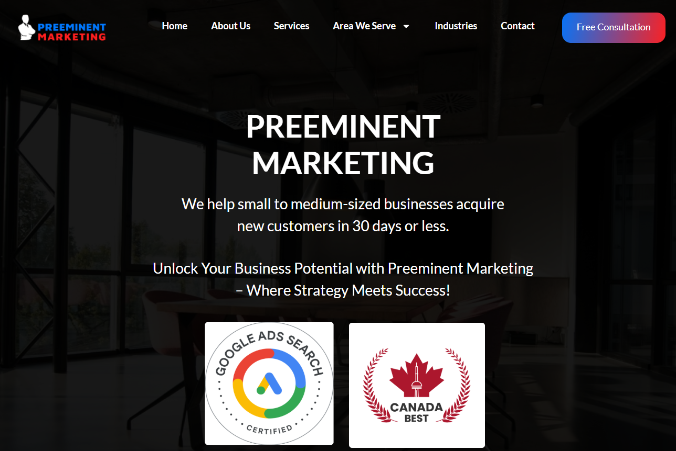
Preeminent Marketing positions itself around budgeting discipline and geographic/demographic targeting for Brampton advertisers. Services include keyword research, ad copywriting with A/B testing, bid management, and ongoing campaign adjustments based on performance data. The agency, based out of North York, emphasizes setting spending ceilings so clients aren't caught off guard by runaway ad costs, and it markets itself toward small and medium-sized businesses specifically. That budget-conscious framing may suit business owners who are more nervous about overspending than about squeezing out every last percentage point of ROAS.
🌐Website: Preeminentmarketing.ca
📍Location: 251 Consumers Rd Suite 1200 North York, ON M2J 4R3, Canada
📞Contact: +1 647-270-8468

9. 2Marketing
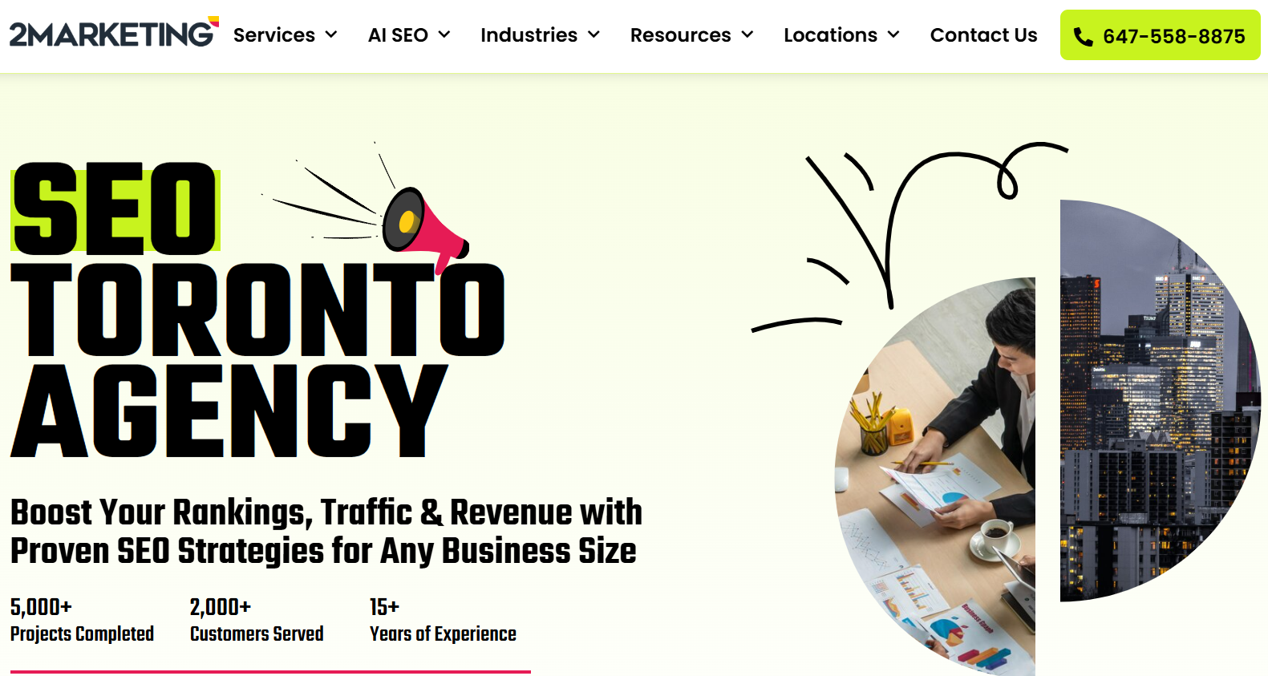
Based in Toronto and serving Brampton and the surrounding GTA, 2Marketing offers a fairly traditional full-service PPC package - search ads, shopping ads, remarketing, Bing advertising, and social/display advertising - alongside web design and SEO, positioning itself as a one-stop shop for businesses that want their web presence and ad campaigns managed together. The agency emphasizes a customized, non-templated approach, saying it starts each engagement by learning about a client's brand, products, and past challenges before building a campaign strategy. They also list experience across a range of industries, from healthcare and legal to e-commerce and home services, which points to broad rather than niche specialization.
🌐Website: 2marketing.com
📍Location: 300 Supertest Rd, Toronto, ON Canada M3J 2M2
📞Contact: 647-558-8875

10. Toronto SEO Services
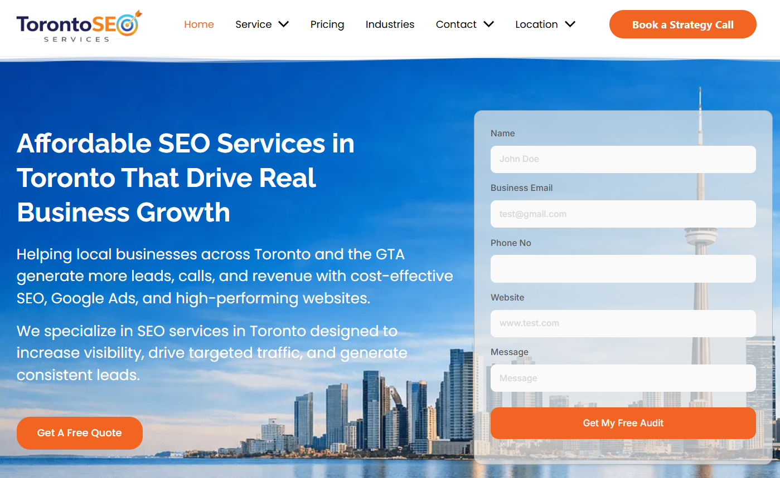
Rounding out the list, Toronto SEO Services offers Google Ads management aimed specifically at small and brick-and-mortar businesses in Brampton, with an emphasis on affordability and no long-term contracts. Their pitch focuses on solving common small-business pain points - low visibility on Google, weak or outdated websites, and inconsistent lead flow - rather than more advanced enterprise-style features. They also serve nearby markets like Mississauga and Vaughan, and their lack of long-term contracts can lower the risk for owners who are testing paid ads for the first time on a limited budget and want the flexibility to walk away if results don't materialize.
🌐Website: Torontoseoservices.com
📍Location: N/A
📞Contact: N/A

How to Choose the Right PPC Agency for Your Brampton Business
A few things worth checking before you sign with any agency:
- Do they lead with strategy or with spend? An agency that wants to understand your numbers before launching a campaign is generally a safer bet than one that starts spending immediately.
- Are they transparent about performance? You should get regular reports built around cost per lead, ROAS, and actual sales - not just clicks and impressions.
- Will they tell you "not yet"? The best agencies will be honest if your offer, budget, or website isn't ready for paid traffic yet.
- Do they understand Brampton specifically? Local market knowledge affects targeting, budget allocation, and messaging.

Ready to Stop Wasting Ad Spend?
If you're comparing PPC agencies in Brampton, it's worth starting with a free audit so you know exactly where your current ad budget is going - and where it's leaking. At Cremsocial, we build every campaign around one goal: profit. If your ads aren't bringing back more than they cost, we change them until they do.
Get your free ads audit from Cremsocial today and find out what your ad budget could really be doing for your business.

Frequently Asked Questions
1. How much should a Brampton business budget for Google Ads?
It varies by industry and competition, but many local businesses start with a few thousand dollars a month to gather enough data, then scale once they know their cost per lead and ROAS.
2. How fast will I see results from PPC advertising?
Traffic and leads can start almost immediately, though the first week or two is usually a learning period. Stable, meaningful results typically show up within 30 to 60 days.
3. Is Google Ads or social media advertising better for my business? Google Ads is strongest for capturing people actively searching for what you offer. Social platforms are better for building awareness with people who aren't searching yet. Many businesses use both.
4. What's a good return on ad spend (ROAS)?
A common benchmark is 4:1, but the right number depends on your margins. What matters most is whether your ads are actually profitable for your business, not a generic average.
5. Will PPC work if I only have a small budget?
Yes - it just means starting narrower: a tighter local radius, fewer high-intent keywords, and a more selective platform mix.
6. What happens if my ad campaign isn't performing?
A good agency adjusts bids, targeting, and creative continuously rather than waiting for the monthly report, and will tell you honestly if paid ads aren't the right fit yet.

